**МІНІСТЕРСТВО ОСВІТИ І НАУКИ УКРАЇНИ**

**НАЦІОНАЛЬНОМУ УНІВЕРСИТЕТІ “ЛЬВІВСЬКА ПОЛІТЕХНІКА”**

**Лабораторна робота №6**

з дисципліни

«Людино-машинна взаємодія»

**Виконав:**

студент групи КН-308

Гецянин Дмитро

**Викладач:**

Маркелов О.Е.

**Мета виконання лабраторної роботи**

Метою роботи є ознайомлення зі способами, методами та засобами програмування користувацьких інтерфейсів та набуття студентами практичних навичок програмування спеціалізованою мовою XAML інтерактивної взаємодії користувача, опису функціонування діалогів інтерфейсів із наборів програмних елементі інтерфейсу користувача. У результаті виконання лабораторної роботи студенти повинні:

• знати методи та підходи для створення користувацьких інтерфейсів спеціалізованою мовою програмування XAML;

• вміти правильно задавати значення властивостей програмних елементів для різних типів інтерактивної взаємодію; правильно вибирати керуючі події елементів.

**Завдання**

Створити новий проект для десктопної програми.

І у редакторі візуальних форм вікон створити вікна для свого варіанта на основі нових придуманих із ескізів із лаб.4. Експортувати програмний код форм у XAML коді. Зробити скріни побудованих віконних форм.

Код файлів проекту:

**Connect**

<Global.Microsoft.VisualBasic.CompilerServices.DesignerGenerated()> _

**Partial** **Class** Connect

**Inherits** System.Windows.Forms.Form

*'Form overrides dispose to clean up the component list.*

<System.Diagnostics.DebuggerNonUserCode()> _

**Protected** **Overrides** **Sub** Dispose(**ByVal** disposing **As** **Boolean**)

**Try**

**If** disposing **AndAlso** components **IsNot** **Nothing** **Then**

components.Dispose()

**End** **If**

**Finally**

**MyBase**.Dispose(disposing)

**End** **Try**

**End** **Sub**

*'Required by the Windows Form Designer*

**Private** components **As** System.ComponentModel.IContainer

*'NOTE: The following procedure is required by the Windows Form Designer*

*'It can be modified using the Windows Form Designer.*

*'Do not modify it using the code editor.*

<System.Diagnostics.DebuggerStepThrough()> _

**Private** **Sub** InitializeComponent()

**Me**.components = **New** System.ComponentModel.Container()

**Dim** resources **As** System.ComponentModel.ComponentResourceManager = **New** System.ComponentModel.ComponentResourceManager(**GetType**(Connect))

**Me**.ImageList1 = **New** System.Windows.Forms.ImageList(**Me**.components)

**Me**.TextBox1 = **New** System.Windows.Forms.TextBox()

**Me**.Label1 = **New** System.Windows.Forms.Label()

**Me**.TextBox2 = **New** System.Windows.Forms.TextBox()

**Me**.Label2 = **New** System.Windows.Forms.Label()

**Me**.RadioButton1 = **New** System.Windows.Forms.RadioButton()

**Me**.Label3 = **New** System.Windows.Forms.Label()

**Me**.TextBox3 = **New** System.Windows.Forms.TextBox()

**Me**.Label4 = **New** System.Windows.Forms.Label()

**Me**.TextBox4 = **New** System.Windows.Forms.TextBox()

**Me**.Label5 = **New** System.Windows.Forms.Label()

**Me**.TextBox5 = **New** System.Windows.Forms.TextBox()

**Me**.Label6 = **New** System.Windows.Forms.Label()

**Me**.TextBox6 = **New** System.Windows.Forms.TextBox()

**Me**.Label7 = **New** System.Windows.Forms.Label()

**Me**.TextBox7 = **New** System.Windows.Forms.TextBox()

**Me**.MenuStrip1 = **New** System.Windows.Forms.MenuStrip()

**Me**.ConnectToolStripMenuItem = **New** System.Windows.Forms.ToolStripMenuItem()

**Me**.ConnectToToolStripMenuItem = **New** System.Windows.Forms.ToolStripMenuItem()

**Me**.DisconnectToolStripMenuItem = **New** System.Windows.Forms.ToolStripMenuItem()

**Me**.ToolStripSeparator1 = **New** System.Windows.Forms.ToolStripSeparator()

**Me**.ExitToolStripMenuItem = **New** System.Windows.Forms.ToolStripMenuItem()

**Me**.ViewToolStripMenuItem = **New** System.Windows.Forms.ToolStripMenuItem()

**Me**.ReloadToolStripMenuItem = **New** System.Windows.Forms.ToolStripMenuItem()

**Me**.ReloadDataToolStripMenuItem = **New** System.Windows.Forms.ToolStripMenuItem()

**Me**.ToolStripSeparator2 = **New** System.Windows.Forms.ToolStripSeparator()

**Me**.ActualSizeToolStripMenuItem = **New** System.Windows.Forms.ToolStripMenuItem()

**Me**.ZoomInToolStripMenuItem = **New** System.Windows.Forms.ToolStripMenuItem()

**Me**.ZoomOutToolStripMenuItem = **New** System.Windows.Forms.ToolStripMenuItem()

**Me**.ToolStripSeparator3 = **New** System.Windows.Forms.ToolStripSeparator()

**Me**.ToogleDevToolsToolStripMenuItem = **New** System.Windows.Forms.ToolStripMenuItem()

**Me**.HelpToolStripMenuItem = **New** System.Windows.Forms.ToolStripMenuItem()

**Me**.OnlineHelpToolStripMenuItem = **New** System.Windows.Forms.ToolStripMenuItem()

**Me**.PrivacyToolStripMenuItem = **New** System.Windows.Forms.ToolStripMenuItem()

**Me**.PluginsToolStripMenuItem = **New** System.Windows.Forms.ToolStripMenuItem()

**Me**.ToolStripSeparator4 = **New** System.Windows.Forms.ToolStripSeparator()

**Me**.AboutToolStripMenuItem = **New** System.Windows.Forms.ToolStripMenuItem()

**Me**.Label8 = **New** System.Windows.Forms.Label()

**Me**.PictureBox1 = **New** System.Windows.Forms.PictureBox()

**Me**.Button4 = **New** System.Windows.Forms.Button()

**Me**.MenuStrip1.SuspendLayout()

**CType**(**Me**.PictureBox1, System.ComponentModel.ISupportInitialize).BeginInit()

**Me**.SuspendLayout()

*'*

*'ImageList1*

*'*

**Me**.ImageList1.ImageStream = **CType**(resources.GetObject("ImageList1.ImageStream"), System.Windows.Forms.ImageListStreamer)

**Me**.ImageList1.TransparentColor = System.Drawing.Color.Transparent

**Me**.ImageList1.Images.SetKeyName(0, "icons8-available-updates-500.png")

**Me**.ImageList1.Images.SetKeyName(1, "icons8-back-500.png")

**Me**.ImageList1.Images.SetKeyName(2, "icons8-home-500.png")

**Me**.ImageList1.Images.SetKeyName(3, "icons8-lightning-bolt-500.png")

**Me**.ImageList1.Images.SetKeyName(4, "icons8-menu-vertical-500.png")

**Me**.ImageList1.Images.SetKeyName(5, "icons8-more-than-500.png")

**Me**.ImageList1.Images.SetKeyName(6, "icons8-star-500.png")

*'*

*'TextBox1*

*'*

**Me**.TextBox1.Location = **New** System.Drawing.Point(113, 106)

**Me**.TextBox1.Name = "TextBox1"

**Me**.TextBox1.Size = **New** System.Drawing.Size(213, 20)

**Me**.TextBox1.TabIndex = 3

*'*

*'Label1*

*'*

**Me**.Label1.AutoSize = **True**

**Me**.Label1.Location = **New** System.Drawing.Point(51, 113)

**Me**.Label1.Name = "Label1"

**Me**.Label1.Size = **New** System.Drawing.Size(55, 13)

**Me**.Label1.TabIndex = 7

**Me**.Label1.Text = "Hostname"

*'*

*'TextBox2*

*'*

**Me**.TextBox2.Location = **New** System.Drawing.Point(113, 128)

**Me**.TextBox2.Name = "TextBox2"

**Me**.TextBox2.Size = **New** System.Drawing.Size(213, 20)

**Me**.TextBox2.TabIndex = 3

*'*

*'Label2*

*'*

**Me**.Label2.AutoSize = **True**

**Me**.Label2.Location = **New** System.Drawing.Point(80, 135)

**Me**.Label2.Name = "Label2"

**Me**.Label2.Size = **New** System.Drawing.Size(26, 13)

**Me**.Label2.TabIndex = 7

**Me**.Label2.Text = "Port"

*'*

*'RadioButton1*

*'*

**Me**.RadioButton1.AutoSize = **True**

**Me**.RadioButton1.Location = **New** System.Drawing.Point(94, 154)

**Me**.RadioButton1.Name = "RadioButton1"

**Me**.RadioButton1.Size = **New** System.Drawing.Size(85, 17)

**Me**.RadioButton1.TabIndex = 8

**Me**.RadioButton1.TabStop = **True**

**Me**.RadioButton1.Text = "SRV Record"

**Me**.RadioButton1.UseVisualStyleBackColor = **True**

*'*

*'Label3*

*'*

**Me**.Label3.AutoSize = **True**

**Me**.Label3.Location = **New** System.Drawing.Point(32, 205)

**Me**.Label3.Name = "Label3"

**Me**.Label3.Size = **New** System.Drawing.Size(75, 13)

**Me**.Label3.TabIndex = 7

**Me**.Label3.Text = "Authentication"

*'*

*'TextBox3*

*'*

**Me**.TextBox3.Location = **New** System.Drawing.Point(113, 198)

**Me**.TextBox3.Name = "TextBox3"

**Me**.TextBox3.Size = **New** System.Drawing.Size(214, 20)

**Me**.TextBox3.TabIndex = 9

*'*

*'Label4*

*'*

**Me**.Label4.AutoSize = **True**

**Me**.Label4.Location = **New** System.Drawing.Point(12, 227)

**Me**.Label4.Name = "Label4"

**Me**.Label4.Size = **New** System.Drawing.Size(95, 17)

**Me**.Label4.TabIndex = 7

**Me**.Label4.Text = "Read Preferences"

**Me**.Label4.TextAlign = System.Drawing.ContentAlignment.TopRight

**Me**.Label4.UseCompatibleTextRendering = **True**

*'*

*'TextBox4*

*'*

**Me**.TextBox4.Location = **New** System.Drawing.Point(113, 224)

**Me**.TextBox4.Name = "TextBox4"

**Me**.TextBox4.Size = **New** System.Drawing.Size(214, 20)

**Me**.TextBox4.TabIndex = 9

*'*

*'Label5*

*'*

**Me**.Label5.AutoSize = **True**

**Me**.Label5.Location = **New** System.Drawing.Point(80, 257)

**Me**.Label5.Name = "Label5"

**Me**.Label5.Size = **New** System.Drawing.Size(27, 13)

**Me**.Label5.TabIndex = 7

**Me**.Label5.Text = "SSL"

*'*

*'TextBox5*

*'*

**Me**.TextBox5.Location = **New** System.Drawing.Point(113, 250)

**Me**.TextBox5.Name = "TextBox5"

**Me**.TextBox5.Size = **New** System.Drawing.Size(214, 20)

**Me**.TextBox5.TabIndex = 9

*'*

*'Label6*

*'*

**Me**.Label6.AutoSize = **True**

**Me**.Label6.Location = **New** System.Drawing.Point(42, 283)

**Me**.Label6.Name = "Label6"

**Me**.Label6.Size = **New** System.Drawing.Size(65, 13)

**Me**.Label6.TabIndex = 7

**Me**.Label6.Text = "SSH Tunnel"

*'*

*'TextBox6*

*'*

**Me**.TextBox6.Location = **New** System.Drawing.Point(113, 276)

**Me**.TextBox6.Name = "TextBox6"

**Me**.TextBox6.Size = **New** System.Drawing.Size(213, 20)

**Me**.TextBox6.TabIndex = 9

*'*

*'Label7*

*'*

**Me**.Label7.AutoSize = **True**

**Me**.Label7.Location = **New** System.Drawing.Point(33, 309)

**Me**.Label7.Name = "Label7"

**Me**.Label7.Size = **New** System.Drawing.Size(76, 13)

**Me**.Label7.TabIndex = 7

**Me**.Label7.Text = "Favorite Name"

*'*

*'TextBox7*

*'*

**Me**.TextBox7.Location = **New** System.Drawing.Point(113, 302)

**Me**.TextBox7.Name = "TextBox7"

**Me**.TextBox7.Size = **New** System.Drawing.Size(213, 20)

**Me**.TextBox7.TabIndex = 9

*'*

*'MenuStrip1*

*'*

**Me**.MenuStrip1.Items.AddRange(**New** System.Windows.Forms.ToolStripItem() {**Me**.ConnectToolStripMenuItem, **Me**.ViewToolStripMenuItem, **Me**.HelpToolStripMenuItem})

**Me**.MenuStrip1.Location = **New** System.Drawing.Point(0, 0)

**Me**.MenuStrip1.Name = "MenuStrip1"

**Me**.MenuStrip1.Size = **New** System.Drawing.Size(398, 24)

**Me**.MenuStrip1.TabIndex = 12

**Me**.MenuStrip1.Text = "MenuStrip1"

*'*

*'ConnectToolStripMenuItem*

*'*

**Me**.ConnectToolStripMenuItem.DropDownItems.AddRange(**New** System.Windows.Forms.ToolStripItem() {**Me**.ConnectToToolStripMenuItem, **Me**.DisconnectToolStripMenuItem, **Me**.ToolStripSeparator1, **Me**.ExitToolStripMenuItem})

**Me**.ConnectToolStripMenuItem.Name = "ConnectToolStripMenuItem"

**Me**.ConnectToolStripMenuItem.Size = **New** System.Drawing.Size(64, 20)

**Me**.ConnectToolStripMenuItem.Text = "Connect"

*'*

*'ConnectToToolStripMenuItem*

*'*

**Me**.ConnectToToolStripMenuItem.Name = "ConnectToToolStripMenuItem"

**Me**.ConnectToToolStripMenuItem.Size = **New** System.Drawing.Size(142, 22)

**Me**.ConnectToToolStripMenuItem.Text = "Connect to..."

*'*

*'DisconnectToolStripMenuItem*

*'*

**Me**.DisconnectToolStripMenuItem.Name = "DisconnectToolStripMenuItem"

**Me**.DisconnectToolStripMenuItem.Size = **New** System.Drawing.Size(142, 22)

**Me**.DisconnectToolStripMenuItem.Text = "Disconnect"

*'*

*'ToolStripSeparator1*

*'*

**Me**.ToolStripSeparator1.Name = "ToolStripSeparator1"

**Me**.ToolStripSeparator1.Size = **New** System.Drawing.Size(139, 6)

*'*

*'ExitToolStripMenuItem*

*'*

**Me**.ExitToolStripMenuItem.Name = "ExitToolStripMenuItem"

**Me**.ExitToolStripMenuItem.Size = **New** System.Drawing.Size(142, 22)

**Me**.ExitToolStripMenuItem.Text = "Exit"

*'*

*'ViewToolStripMenuItem*

*'*

**Me**.ViewToolStripMenuItem.DropDownItems.AddRange(**New** System.Windows.Forms.ToolStripItem() {**Me**.ReloadToolStripMenuItem, **Me**.ReloadDataToolStripMenuItem, **Me**.ToolStripSeparator2, **Me**.ActualSizeToolStripMenuItem, **Me**.ZoomInToolStripMenuItem, **Me**.ZoomOutToolStripMenuItem, **Me**.ToolStripSeparator3, **Me**.ToogleDevToolsToolStripMenuItem})

**Me**.ViewToolStripMenuItem.Name = "ViewToolStripMenuItem"

**Me**.ViewToolStripMenuItem.Size = **New** System.Drawing.Size(44, 20)

**Me**.ViewToolStripMenuItem.Text = "View"

*'*

*'ReloadToolStripMenuItem*

*'*

**Me**.ReloadToolStripMenuItem.Name = "ReloadToolStripMenuItem"

**Me**.ReloadToolStripMenuItem.Size = **New** System.Drawing.Size(164, 22)

**Me**.ReloadToolStripMenuItem.Text = "Reload"

*'*

*'ReloadDataToolStripMenuItem*

*'*

**Me**.ReloadDataToolStripMenuItem.Name = "ReloadDataToolStripMenuItem"

**Me**.ReloadDataToolStripMenuItem.Size = **New** System.Drawing.Size(164, 22)

**Me**.ReloadDataToolStripMenuItem.Text = "Reload Data"

*'*

*'ToolStripSeparator2*

*'*

**Me**.ToolStripSeparator2.Name = "ToolStripSeparator2"

**Me**.ToolStripSeparator2.Size = **New** System.Drawing.Size(161, 6)

*'*

*'ActualSizeToolStripMenuItem*

*'*

**Me**.ActualSizeToolStripMenuItem.Name = "ActualSizeToolStripMenuItem"

**Me**.ActualSizeToolStripMenuItem.Size = **New** System.Drawing.Size(164, 22)

**Me**.ActualSizeToolStripMenuItem.Text = "Actual Size"

*'*

*'ZoomInToolStripMenuItem*

*'*

**Me**.ZoomInToolStripMenuItem.Name = "ZoomInToolStripMenuItem"

**Me**.ZoomInToolStripMenuItem.Size = **New** System.Drawing.Size(164, 22)

**Me**.ZoomInToolStripMenuItem.Text = "Zoom In"

*'*

*'ZoomOutToolStripMenuItem*

*'*

**Me**.ZoomOutToolStripMenuItem.Name = "ZoomOutToolStripMenuItem"

**Me**.ZoomOutToolStripMenuItem.Size = **New** System.Drawing.Size(164, 22)

**Me**.ZoomOutToolStripMenuItem.Text = "Zoom Out"

*'*

*'ToolStripSeparator3*

*'*

**Me**.ToolStripSeparator3.Name = "ToolStripSeparator3"

**Me**.ToolStripSeparator3.Size = **New** System.Drawing.Size(161, 6)

*'*

*'ToogleDevToolsToolStripMenuItem*

*'*

**Me**.ToogleDevToolsToolStripMenuItem.Name = "ToogleDevToolsToolStripMenuItem"

**Me**.ToogleDevToolsToolStripMenuItem.Size = **New** System.Drawing.Size(164, 22)

**Me**.ToogleDevToolsToolStripMenuItem.Text = "Toogle Dev Tools"

*'*

*'HelpToolStripMenuItem*

*'*

**Me**.HelpToolStripMenuItem.DropDownItems.AddRange(**New** System.Windows.Forms.ToolStripItem() {**Me**.OnlineHelpToolStripMenuItem, **Me**.PrivacyToolStripMenuItem, **Me**.PluginsToolStripMenuItem, **Me**.ToolStripSeparator4, **Me**.AboutToolStripMenuItem})

**Me**.HelpToolStripMenuItem.Name = "HelpToolStripMenuItem"

**Me**.HelpToolStripMenuItem.Size = **New** System.Drawing.Size(44, 20)

**Me**.HelpToolStripMenuItem.Text = "Help"

*'*

*'OnlineHelpToolStripMenuItem*

*'*

**Me**.OnlineHelpToolStripMenuItem.Name = "OnlineHelpToolStripMenuItem"

**Me**.OnlineHelpToolStripMenuItem.Size = **New** System.Drawing.Size(140, 22)

**Me**.OnlineHelpToolStripMenuItem.Text = "Online Help "

*'*

*'PrivacyToolStripMenuItem*

*'*

**Me**.PrivacyToolStripMenuItem.Name = "PrivacyToolStripMenuItem"

**Me**.PrivacyToolStripMenuItem.Size = **New** System.Drawing.Size(140, 22)

**Me**.PrivacyToolStripMenuItem.Text = "Privacy"

*'*

*'PluginsToolStripMenuItem*

*'*

**Me**.PluginsToolStripMenuItem.Name = "PluginsToolStripMenuItem"

**Me**.PluginsToolStripMenuItem.Size = **New** System.Drawing.Size(140, 22)

**Me**.PluginsToolStripMenuItem.Text = "Plugins"

*'*

*'ToolStripSeparator4*

*'*

**Me**.ToolStripSeparator4.Name = "ToolStripSeparator4"

**Me**.ToolStripSeparator4.Size = **New** System.Drawing.Size(137, 6)

*'*

*'AboutToolStripMenuItem*

*'*

**Me**.AboutToolStripMenuItem.Name = "AboutToolStripMenuItem"

**Me**.AboutToolStripMenuItem.Size = **New** System.Drawing.Size(140, 22)

**Me**.AboutToolStripMenuItem.Text = "About"

*'*

*'Label8*

*'*

**Me**.Label8.AutoSize = **True**

**Me**.Label8.Font = **New** System.Drawing.Font("Microsoft Sans Serif", 20.0!, System.Drawing.FontStyle.Regular, System.Drawing.GraphicsUnit.Point, **CType**(204, **Byte**))

**Me**.Label8.ForeColor = System.Drawing.SystemColors.ControlLightLight

**Me**.Label8.Image = **Global**.WindowsApp1.My.Resources.Resources.Screenshot_8

**Me**.Label8.Location = **New** System.Drawing.Point(86, 39)

**Me**.Label8.Name = "Label8"

**Me**.Label8.Size = **New** System.Drawing.Size(210, 31)

**Me**.Label8.TabIndex = 14

**Me**.Label8.Text = "Connect to Host"

*'*

*'PictureBox1*

*'*

**Me**.PictureBox1.Image = **Global**.WindowsApp1.My.Resources.Resources.Screenshot_8

**Me**.PictureBox1.Location = **New** System.Drawing.Point(0, 27)

**Me**.PictureBox1.Name = "PictureBox1"

**Me**.PictureBox1.Size = **New** System.Drawing.Size(398, 61)

**Me**.PictureBox1.TabIndex = 13

**Me**.PictureBox1.TabStop = **False**

*'*

*'Button4*

*'*

**Me**.Button4.BackColor = System.Drawing.SystemColors.ControlLightLight

**Me**.Button4.BackgroundImage = **Global**.WindowsApp1.My.Resources.Resources.Screenshot_2

**Me**.Button4.Font = **New** System.Drawing.Font("Microsoft Sans Serif", 12.0!, System.Drawing.FontStyle.Regular, System.Drawing.GraphicsUnit.Point, **CType**(204, **Byte**))

**Me**.Button4.Location = **New** System.Drawing.Point(247, 343)

**Me**.Button4.Name = "Button4"

**Me**.Button4.Size = **New** System.Drawing.Size(80, 32)

**Me**.Button4.TabIndex = 11

**Me**.Button4.Text = "Connect"

**Me**.Button4.UseVisualStyleBackColor = **False**

*'*

*'Form1*

*'*

**Me**.AutoScaleDimensions = **New** System.Drawing.SizeF(6.0!, 13.0!)

**Me**.AutoScaleMode = System.Windows.Forms.AutoScaleMode.Font

**Me**.BackColor = System.Drawing.SystemColors.ControlLight

**Me**.ClientSize = **New** System.Drawing.Size(398, 387)

**Me**.Controls.Add(**Me**.Label8)

**Me**.Controls.Add(**Me**.PictureBox1)

**Me**.Controls.Add(**Me**.MenuStrip1)

**Me**.Controls.Add(**Me**.Button4)

**Me**.Controls.Add(**Me**.TextBox7)

**Me**.Controls.Add(**Me**.TextBox6)

**Me**.Controls.Add(**Me**.Label7)

**Me**.Controls.Add(**Me**.TextBox5)

**Me**.Controls.Add(**Me**.Label6)

**Me**.Controls.Add(**Me**.TextBox4)

**Me**.Controls.Add(**Me**.Label5)

**Me**.Controls.Add(**Me**.TextBox3)

**Me**.Controls.Add(**Me**.Label4)

**Me**.Controls.Add(**Me**.RadioButton1)

**Me**.Controls.Add(**Me**.Label3)

**Me**.Controls.Add(**Me**.Label2)

**Me**.Controls.Add(**Me**.Label1)

**Me**.Controls.Add(**Me**.TextBox2)

**Me**.Controls.Add(**Me**.TextBox1)

**Me**.Name = "Form1"

**Me**.Text = "Form1"

**Me**.MenuStrip1.ResumeLayout(**False**)

**Me**.MenuStrip1.PerformLayout()

**CType**(**Me**.PictureBox1, System.ComponentModel.ISupportInitialize).EndInit()

**Me**.ResumeLayout(**False**)

**Me**.PerformLayout()

**End** **Sub**

**Friend** **WithEvents** ImageList1 **As** ImageList

**Friend** **WithEvents** TextBox1 **As** TextBox

**Friend** **WithEvents** Label1 **As** Label

**Friend** **WithEvents** TextBox2 **As** TextBox

**Friend** **WithEvents** Label2 **As** Label

**Friend** **WithEvents** RadioButton1 **As** RadioButton

**Friend** **WithEvents** Label3 **As** Label

**Friend** **WithEvents** TextBox3 **As** TextBox

**Friend** **WithEvents** Label4 **As** Label

**Friend** **WithEvents** TextBox4 **As** TextBox

**Friend** **WithEvents** Label5 **As** Label

**Friend** **WithEvents** TextBox5 **As** TextBox

**Friend** **WithEvents** Label6 **As** Label

**Friend** **WithEvents** TextBox6 **As** TextBox

**Friend** **WithEvents** Label7 **As** Label

**Friend** **WithEvents** TextBox7 **As** TextBox

**Friend** **WithEvents** Button4 **As** Button

**Friend** **WithEvents** MenuStrip1 **As** MenuStrip

**Friend** **WithEvents** ConnectToolStripMenuItem **As** ToolStripMenuItem

**Friend** **WithEvents** ConnectToToolStripMenuItem **As** ToolStripMenuItem

**Friend** **WithEvents** DisconnectToolStripMenuItem **As** ToolStripMenuItem

**Friend** **WithEvents** ToolStripSeparator1 **As** ToolStripSeparator

**Friend** **WithEvents** ExitToolStripMenuItem **As** ToolStripMenuItem

**Friend** **WithEvents** ViewToolStripMenuItem **As** ToolStripMenuItem

**Friend** **WithEvents** ReloadToolStripMenuItem **As** ToolStripMenuItem

**Friend** **WithEvents** ReloadDataToolStripMenuItem **As** ToolStripMenuItem

**Friend** **WithEvents** ToolStripSeparator2 **As** ToolStripSeparator

**Friend** **WithEvents** ActualSizeToolStripMenuItem **As** ToolStripMenuItem

**Friend** **WithEvents** ZoomInToolStripMenuItem **As** ToolStripMenuItem

**Friend** **WithEvents** ZoomOutToolStripMenuItem **As** ToolStripMenuItem

**Friend** **WithEvents** ToolStripSeparator3 **As** ToolStripSeparator

**Friend** **WithEvents** ToogleDevToolsToolStripMenuItem **As** ToolStripMenuItem

**Friend** **WithEvents** HelpToolStripMenuItem **As** ToolStripMenuItem

**Friend** **WithEvents** OnlineHelpToolStripMenuItem **As** ToolStripMenuItem

**Friend** **WithEvents** PrivacyToolStripMenuItem **As** ToolStripMenuItem

**Friend** **WithEvents** PluginsToolStripMenuItem **As** ToolStripMenuItem

**Friend** **WithEvents** ToolStripSeparator4 **As** ToolStripSeparator

**Friend** **WithEvents** AboutToolStripMenuItem **As** ToolStripMenuItem

**Friend** **WithEvents** PictureBox1 **As** PictureBox

**Friend** **WithEvents** Label8 **As** Label

**End** **Class**

[API](http://hilite.me/api) • [Code](https://github.com/alexkay/hilite.me) • Made by [Alexander Kojevnikov](http://kojevnikov.com/) • Powered by [Flask](http://flask.pocoo.org/)

**Connect.vb**

Public Class Connect

Private Sub Button4_Click(sender As Object, e As EventArgs) Handles Button4.Click

Dim box = New Databases()

box.Show()

End Sub

End Class

**Databases.vb**

Public Class Databases

Dim thedatatable As New DataTable

Private Sub Button1_Click(ByVal sender As System.Object, ByVal e As System.EventArgs) Handles Button1.Click

ContextMenuStrip1.Show(Button1, Button1.Location.X, Button1.Location.Y - 40)

End Sub

Private Sub Button2_Click(sender As Object, e As EventArgs) Handles Button2.Click

ContextMenuStrip2.Show(Button1, Button1.Location.X, Button1.Location.Y + 5)

End Sub

Private Sub Button3_Click(sender As Object, e As EventArgs) Handles Button3.Click

ContextMenuStrip3.Show(Button1, Button1.Location.X, Button1.Location.Y + 50)

Dim box = New Collection()

box.Show()

End Sub

Private Sub Button4_Click(sender As Object, e As EventArgs) Handles Button4.Click

Dim box = New crDatabase()

box.Show()

End Sub

End Class

**Collection.vb**

Public Class Collection

Private Sub Button4_Click(sender As Object, e As EventArgs) Handles Button4.Click

Dim box = New crCollection()

box.Show()

End Sub

End Class

**crCollection.vb**

Public Class crCollection

Private Sub Button1_Click(sender As Object, e As EventArgs) Handles Button1.Click

Me.Close()

End Sub

End Class

**crDatabase.vb**

Public Class crDatabase

Private Sub Button1_Click(sender As Object, e As EventArgs) Handles Button1.Click

Me.Close()

End Sub

End Class

**Скріни програми**

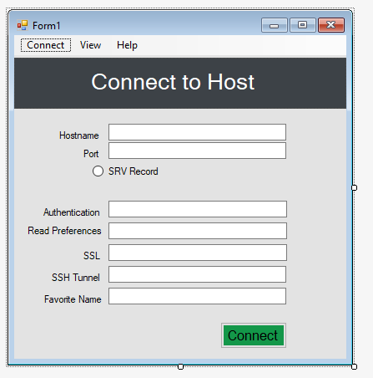

Рис.1. Connect to Host

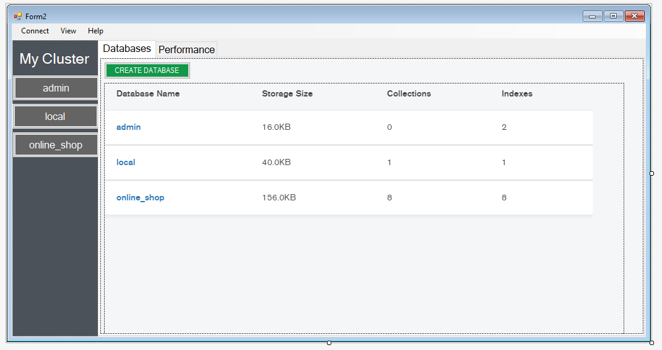

Рис.2. Databases

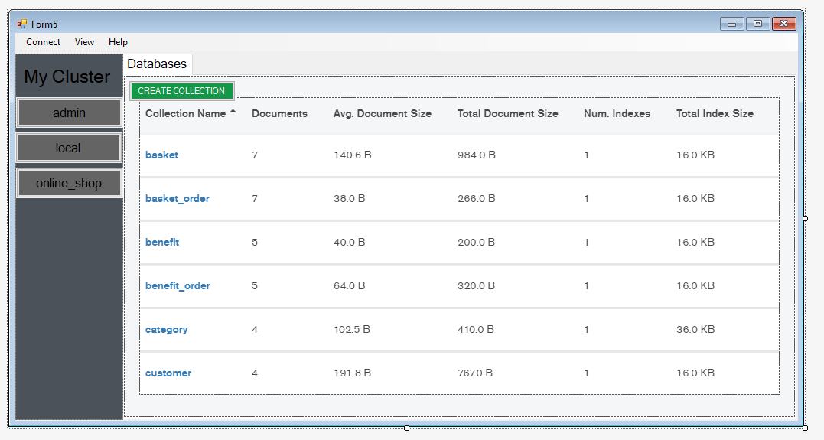

Рис.3 Collections

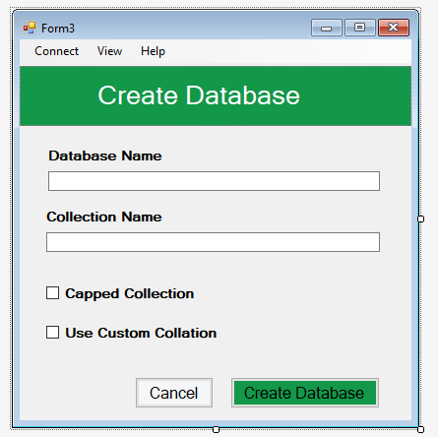

Рис.4. Create Database

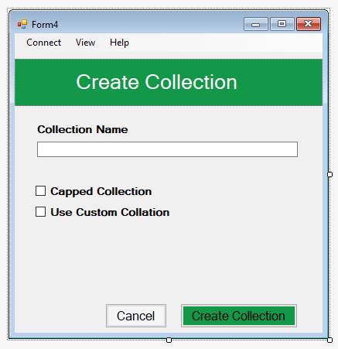

Рис.5. Create Collection

**Висновок:** у цій лабораторній роботі яознайомився зі способами, методами та засобами програмування користувацьких інтерфейсів та набув практичних навичок програмування спеціалізованою мовою XAML інтерактивної взаємодії користувача, опису функціонування діалогів інтерфейсів із наборів програмних елементі інтерфейсу користувача.